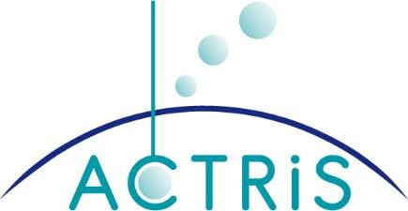
LETTER OF INTENT
2021

For collaborating in setting up the Aerosol, Clouds, and Trace Gases Research Infrastructure (ACTRIS) as a European research infrastructure

The Ministry of / Research Council [-] of [country]: (To be modified and filled by the signatory concerned)

- Recognises the national investments and work carried out so far to establish and develop the Aerosol, Clouds, and Trace gases Research Infrastructure (ACTRIS) and the inclusion of ACTRIS in the ESFRI (European Strategy Forum on Research Infrastructures) roadmap 2016.

- Declares its willingness to work actively and constructively in order to set up ACTRIS as a sustainable European research infrastructure and with the aim of creating a legal entity with full legal capacity.

- Declares that it shall endeavour to support its relevant national institutions in setting up ACTRIS.

- Recognises that an Interim ACTRIS Council (IAC) has been set up to prepare, discuss and approve strategic issues for establishing ACTRIS. Countries having signed the Letter of Political Support to the ACTRIS ESFRI proposal shall be directly considered as IAC members. Other countries may enter the IAC as members by signing this Letter of Intent.

- Recognises that the financial plan of ACTRIS as a sustainable European research infrastructure will be defined and approved in IAC.

- Recognises that the ACTRIS will have the following structure:
  - Head Office
  - Distributed European Central Facilities, including ACTRIS Data Centre and Topical Centres
  - ACTRIS National Facilities.

- This Letter of Intent shall be in force until ACTRIS ERIC is established or ten (10) years from the date it was signed, whichever is earlier.

- The Ministry of Education and Culture in Finland shall be the depository of all signed Letters of Intent.

- This Letter of Intent does not create any legally binding obligations to the signatories.

SIGNATURE, PLACE AND DATE

